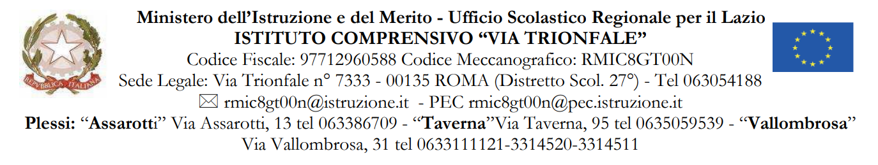
MODULO 3: RELAZIONE USCITE DIDATTICHE

AL DIRIGENTE SCOLASTICO
dell’I.C. “via Trionfale”

USCITA DIDATTICA ___________________________________________________________

IN DATA _____/____/_________

CLASSI PARTECIPANTI: ___________________________ NUMERO ALUNNI ______________

PUNTI DI FORZA _______________________________________________________________
______________________________________________________________________________
______________________________________________________________________________
______________________________________________________________________________

PUNTI DI DEBOLEZZA __________________________________________________________
______________________________________________________________________________
______________________________________________________________________________
______________________________________________________________________________

VALIDAZIONE FORMATIVA ______________________________________________________
______________________________________________________________________________
______________________________________________________________________________
______________________________________________________________________________

L’USCITA E’ CONSIGLIABILE

NON E’ CONSIGLIABILE

DATA ____/____/_________

IL COORDINATORE DI CLASSE

NULLA OSTA della DIREZIONE (SI/NO) ………………..………………………………………………………

